A Progress Report for Donor X

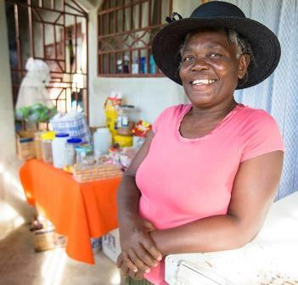

Elvire Léger opened a small shop with a loan from her CARE-sponsored village savings and loan group. Since the earthquake, CARE has overseen the creation of 1,213 groups like hers, comprising more than 33,000 members. By managing and investing their own savings, earthquake survivors regain economic self-sufficiency and bolster their resilience in the event of future natural disasters.

Haiti Earthquake Emergency Response Fund

January 2010 – December 2014

Introduction

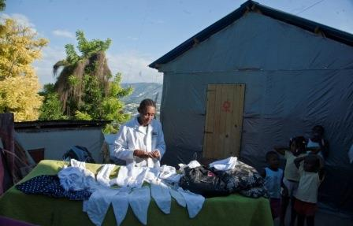
On January 12, 2010, Haiti was struck by a magnitude 7.0 earthquake, devastating its capital, Port-au-Prince, and surrounding areas. The quake affected more than 2 million Haitians, claimed over 200,000 lives, and left 300,000 injured. At the height of the crisis, more than 1.5 million newly homeless people were sheltering in some 1,500 spontaneous settlements. The earthquake indirectly affected the entire country, sending 570,000 people fleeing for the provinces and setting off shock waves through the economy.
CARE’s transitional shelter program prioritized female heads of household, like Gellia Voltaire, 63. Each family participated in building their own shelter by enlisting five volunteers. CARE provided materials and two trained carpenters. The structures are designed as modules that can be expanded and integrated into permanent homes.

The scale and impact of the disaster were unprecedented for the Caribbean nation, already the poorest in the western hemisphere. The capital of this highly-centralized country lay in ruins, as did the government ministries that would normally work with the international community on the response.

The magnitude of the destruction resulted in a strong outpouring of generosity from the public worldwide. Immediately after the earthquake, CARE launched a global appeal and our emergency response team made sure vital life-saving supplies reached those most in need.

CARE focused on five key relief sectors: emergency shelter; sexual and reproductive health; water, sanitation and hygiene; education; and food security. We concentrated on the heavily affected areas of Carrefour and Léogâne, near the earthquake’s epicenter, with additional interventions in indirectly affected areas. CARE immediately distributed emergency relief supplies, providing food, clean water, temporary shelter, and other services to more than 300,000 people within the first four months. Over the longer term, we are working to rebuild and improve livelihoods and help Haitians become more resilient in the face of future disasters.

The earthquake was the most devastating emergency CARE had responded to since the 2004 Indian Ocean tsunami. While we have achieved much in the intervening five years, the task of rebuilding is ongoing. CARE remains committed to working with Haitians as they strive to build a better future.

CARE’s Response

Over the last five years, CARE has transitioned from post-earthquake emergency relief into programming aimed at addressing the underlying causes of poverty that increase vulnerability to disaster. Our efforts have focused on sustainable economic development, rebuilding of the urban fabric, improved education and food security.

Working together, the international community, local groups and the Haitian government have helped more than 1.45 million people return from displacement, and every day more are moving to safer housing. CARE has enabled over 22,900 people to access transitional and permanent shelter, and continues to work with partners to find alternative solutions for those still living in desperate conditions.

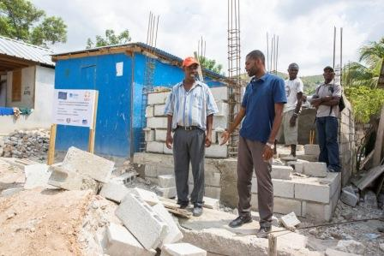
The effects of the earthquake were compounded by subsequent disasters, including a cholera epidemic, hurricanes and tropical storms, and drought. CARE has responded by supplying water, building sanitation infrastructure, distributing emergency shelters and hygiene supplies, and providing food vouchers to thousands of affected families. As rising food prices, climate change and disasters force families further into poverty, CARE’s work will continue to focus on local resilience building in the years to come.
CARE supervisor Marceau Jocelyn (left) and volunteer Emmanuel Beauvoir, at a new water access point CARE is building in Carrefour. CARE works to strengthen local community groups like Emmanuel’s, helping them develop skills to manage future development efforts. They choose the infrastructure projects, participate in every step of planning and construction, and take ownership over the long term.

The sections that follow highlight our immediate response, the transitions of CARE’s programming in Haiti as the country recovers, and CARE’s response to new vulnerabilities when they arise.

Shelter

CARE has met the immediate shelter needs of 179,750 people in the last five years and has supported 4,583 families with longer-term shelter solutions, reaching over 22,900 people.

Response highlights
- 35,950 families received emergency shelter assistance (including after Hurricanes Sandy and Isaac)
- 2,550 transitional shelter kits distributed, providing housing for 13,400 people
- 500 rural house repair kits distributed
- 598 families completed house retrofits
- 925 families supported to leave camps for safe homes
- 10 “build-back-better” model houses constructed
- 150 families reached through construction clinics to improve construction quality
- 175 construction workers trained, including 88 women
- 35,000 people will benefit over the next two years from neighborhood improvements

Immediately after the earthquake, CARE distributed eemergency shelters and non-food relief items to displaced families in Carrefour and Léogâne, two of the most severely affected areas. We also distributed 2,550 hurricane-resistant transitional shelters and provided 500 families in rural areas with house repair kits comprised of wood, cement, tools, and training on safer building techniques.
Neighbor to neighbor

On the porch of her new residence, Angélène Jean, 30, watches her four children and tends a small shop selling groceries, soap and toiletries, while her husband is fishing. Until recently her family and thirty others were crowded into tents and makeshift shelters near a rocky beach where men repair their nets and unload the day’s catch. “We lived under a tarp for four years. People were sick, and the heat was terrible,” says Angélène.

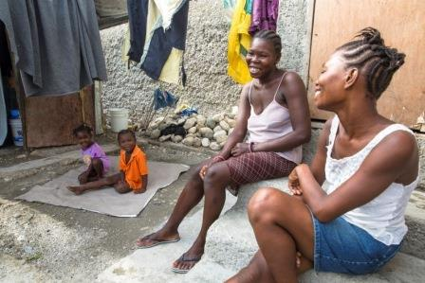
CARE’s retrofit program has been empowering camp residents to find housing alternatives since 2012. A family living in a camp finds a homeowner whose house is damaged. In exchange for financial and technical assistance to repair their houses, homeowners agree to host the family rent-free for 12 to 24 months. Homeowners manage the project, which provides structural repairs through a technique called retrofit. They purchase materials locally and hire local workers, contributing to the neighborhood economy. CARE’s engineers train the workers, inspect materials and supervise the work.

CARE engages municipal and national government engineers to ensure the work is completed according to earthquake-resistant standards, reinforcing the importance of following regulations. “The skills that remain behind will help make the community more resistant to future disasters,” says Dierry Léger, who has worked with CARE since taking office as deputy mayor of Carrefour in 2012. “There has long been a problem with construction quality, with people building houses without respecting building standards,” he says. “It’s still a challenge getting the bosses to build according to norms, but things have changed.”

Families who participate in the program often seek old friends or neighbors, ensuring the most compatible pairings and building community solidarity for future problem-solving. When CARE presented the approach in her camp, Angélène called on her friend Fleurime Gracia, 30, whose modest house had suffered cracked beams and collapsed walls. In exchange for repair help, Fleurime, her husband and two children happily made room for their neighbors. Everyone is getting along well, says Fleurime. This has always been a tight-knit community.

All of the residents of Angelene’s old camp have found a match. To boost incomes, participants choose productive enterprises – like Angélène’s small retail shop – and CARE provides seed capital and training to get them up and running. “We earn more than we ever did before” she says. “We’re paying school fees for all of our kids, and hoping to save up enough so [my husband] can buy his own fishing equipment.” She’s currently searching for an affordable rental home for after they leave Fleurime’s.

Her two older kids scamper out from the porch, thread their way between the closely placed houses and reach the open field that was crowded with tents and tarps until a few months ago. Today it’s empty, except for an impromptu soccer game.

As the hurricane and rainy seasons approached CARE distributed 20,000 reinforcement kits, which included wood, tarpaulins, tools, fasteners, and metal straps. The kits strengthened emergency shelters for approximately 100,000 displaced people across 86 camps. CARE worked with partners to develop suitable safe shelter awareness materials and trained carpenters and community members.

In our shelter response CARE has provided a variety of options including transitional shelters – an upgradable and reusable structure that families could reassemble or adapt to their needs – house repairs in rural and urban areas, rental subsidies, and newly built permanent housing. We have reached 4,583 families with these types of solutions, and are targeting over 35,000 people over the next two years through our work in participatory urban planning, neighborhood improvements, disaster risk reduction initiatives, and additional housing solutions.

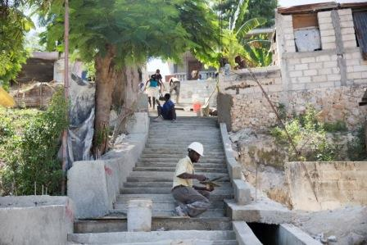
CARE’s comprehensive program of neighborhood improvement promotes sanitation, disaster risk reduction, safer construction methods, adequate infrastructure, improved income options and improved governance in a community of 6,000 households in Carrefour, an earthquake-affected commune in metropolitan Port-au-Prince. One element, an innovative house repair program, provides safe housing for homeowners and simultaneously helps families move out of camps into newly repaired rental units (See insert: Neighbor to Neighbor).
CARE’s Neighborhood Improvement Project provides vital infrastructure in quake-damaged neighborhoods. By including local leaders throughout the planning and execution, we build solidarity and skills that will serve communities for years to come.

CARE provides on-the-job training to construction workers on how to repair damaged buildings to meet safety standards, and mobile construction clinics providing training and advice on safe materials and techniques to homeowners who are rebuilding with their own resources. These clinics reached 150 families, who in turn shared the knowledge with others. The 10 model homes built in the process were made available to particularly vulnerable families.

Safer housing is only part of the solution. CARE’s comprehensive neighborhood improvement includes improving access to water, sanitation and better storm water management; income-generating activities to boost household revenues, protect assets and pay for education costs; access to community savings and loans services to build economic resilience and increase social cohesion; community-based disaster risk reduction; and the promotion of inclusive and accountable governance that ensures the rights of citizens.

Sexual and reproductive health

Response highlights
- Five permanent community centers constructed
- 45,021 people reached with awareness-raising activities through house-to-house visits, meetings with clubs, community gatherings and educational sessions in schools
- 172 peer educators trained and active
- 270 women trained on income generation activities and handcrafts training
- 178 committee structures addressing sexual and reproductive health and gender-based violence established and operational
- 61 village savings and loan associations (VSLAs) established in health programming zone

In the aftermath of the earthquake, the precarious conditions in crowded, poorly lit camps posed particular risks for women and girls, including an increased incidence of gender-based violence, exploitation and abuse. Furthermore, health needs including maternal and neonatal health frequently went unmet.

CARE worked with the populations in spontaneous camps to prevent gender-based violence – already a serious concern prior to the earthquake – and boost sexual and reproductive health. CARE distributed clean delivery kits, newborn kits, hygiene kits, mattresses, blankets, shelter supplies and condoms, and made information on reproductive health available to camp residents, as well as referral networks for health facilities and especially health and protection facilities for victims of sexual violence.

Conditions in destroyed neighborhoods outside of camps were also challenging for women and girls. Early in the response, CARE began to work with communities around the camps creating solidarity links between camp residents and the rest of the population. Over a period of three years CARE created 178 community clubs and solidarity groups comprised of women and men, which became a network for referral, awareness, and support. Trained peer educators provided valuable information on basic reproductive and maternal health, family planning and gender-based violence. CARE constructed five community centers to support health services and create safe spaces for information sharing, discussion, and dialogue, and provided training and in-kind support to local health service providers.

CARE seeks to empower women, engage men and address the lack of economic opportunities which increase vulnerability to exploitation and abuse. In September 2011, CARE launched the village savings and loans association (VSLA) program targeting 30 solidarity groups. VSLAs are self-managed groups of 20 to 30 members, the majority of them women, who pool their savings and then use them to provide loans to each other, funding businesses and income-generating initiatives. Most groups also maintain “social funds” and “emergency funds” to assist members in case of unexpected shocks.

CARE works closely with the Ministry of Women Affairs to promote and protect women’s rights in areas including gender-based violence prevention, women’s empowerment, equity in education, food and nutrition, and protection services for women and girls. The ministry has contributed to the strategic planning of CARE’s programming, and CARE has provided capacity building and advocacy.

Water, sanitation and hygiene

Response highlights
- 1,092,405 cubic meters of chlorinated water provided
- 70,556 hygiene promotion sessions held (home visits, community sessions, community leader sessions, mass community sessions, youth club and hygiene clubs, public health promotion in schools)
- 3,168,810 people reached with hygiene promotion messages
- 19,802,800 water purification tablets (aquatabs) distributed
- 5,925 latrines constructed or rehabilitated
- 228 water points constructed or rehabilitated
- 208,010 packets of oral rehydration salts distributed

Water-borne diseases are a major cause of illness and death, particularly following a disaster. Haiti did not possess a functioning water and sanitation infrastructure even before the earthquake. In the immediate aftermath, CARE worked in 51 camps building latrines, showers, and hand-washing stations, distributing hygiene kits and water purification tablets, and providing water supply. Across all camps, we raised awareness on proper hand-washing practices, safe water management, the importance of hygienic disposal of household solid waste, risks of open defecation, safe latrine use and disease prevention. Beyond our work in camps, CARE provided an additional 1.09 million cubic meters of chlorinated water to neighborhoods of Port-au-Prince serving more than 500,000 people in the metropolitan area.

Over the longer term, CARE works with local residents and authorities to rehabilitate or build durable community-managed water points and build sanitation facilities such as toilets and showers in neighborhoods where we supported transitional shelter and housing repairs, in schools, and in health centers. CARE works with the local and national authorities to ensure that infrastructure follows government standards and can be maintained in the future.

Cholera Epidemic

An outbreak of cholera beginning in October 2010 has affected an estimated 706,089 people and claimed 8,592 lives to date. CARE immediately responded with increased water and sanitation assistance. In displacement camps we continued providing water supply, building latrines and hand-washing stations and reinforcing hygiene promotion. In heavily affected rural areas we focused on cholera prevention, increased safe water and sanitation services, and distribution of soap and water purification tablets. We worked to strengthen the ability of local organizations and trained health center staff to respond.

Since the epidemic CARE has mapped 751 water sources and supported the rehabilitation or protection of 228 water points. To ensure sustainability and community ownership, we strengthen or create committees to manage water systems. We have conducted over 70,000 sessions of cholera prevention and hygiene promotion, promoting healthy behavior and training people on treating and storing drinking water.

Education

Response highlights
- 39,873 children school kits and recreation kits distributed
- 100 schools provided with furniture, equipment and/or teaching materials
- 2,835 psychosocial training sessions provided to parents, teachers and caregivers
- 128 school management committees created comprised of students, teachers, administrators, and community members and trained in organizational development and project management and /or social enterprise development
- 75 school improvement grants provided to complete small-scale school improvement projects such as school beautification, creation of computer labs, and construction of classrooms
- 14,979 out-of-school children identified for the 2014-2015 school year
- 12,707 out-of-school children enrolled for the 2014-2015 school year
- 12 municipal education commissions created

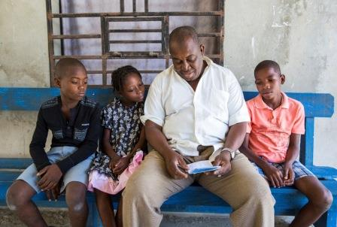
In the immediate wake of the earthquake, CARE Haiti launched a program providing psychosocial and educational support to affected children and their families in 78 schools. We provided school kits to primary school students and teaching materials to schools and immediate emotional support to parents, students and teachers. Following the early distribution phase, the program began to address obstacles to long-term recovery and improved quality education, coaching teachers and school administrators and advocating for child rights. We created and supported school management committees to ensure parental and student participation in the governance and development of schools.
After the quake, CARE provided psychosocial support and financial training to students, parents and staff at the Pyramide school in Léogâne. School administrator Juan Widdy Sanon (pictured) and colleagues then developed a school savings bank. Kids deposit a small sum each week. At the end of the school year the money is paid out to families, who use it to cover educational or other expenses or invest in small enterprises.

Nearly 23 percent of Haiti’s primary school-aged children are out of school. CARE began to work in 2013 with the Ministry of Education and a number of national and international partners to support the ministry’s strategy to increase access, ensure equity, and improve the quality of education. This initiative seeks to address the root causes that keep children out of school, and will enroll and retain 50,000 out-of-school-children for a complete primary cycle of education over the next five years.

CARE has joined forces with Haitian social movements and other partners to advocate for the elimination of domestic servitude in Haiti, a practice that today deprives thousands of children of their rights. The program will ensure that vulnerable children are able to enroll and stay in schools.

To address parents’ lack of means to pay for school fees and supplies, especially given frequent financial shocks caused by disasters CARE will introduce the VSLA model to parents of out-of-school girls and boys as means to increase income and economic resilience.

Food security

Response highlights
- 200,266 food vouchers distributed in food insecure zones
- $7,804,528 transferred in food vouchers to food insecure families, directly benefiting local economies
- 397 local merchants benefited from increased trade thanks to food vouchers

The earthquake had repercussions on all regions in Haiti, as the arrival of displaced populations stretched resources and the economy of the provinces, highly dependent on markets in the capital, came to a halt. Access to goods was limited and supply chains were disrupted, a particular problem in departments like Grand Anse, already hampered by poor market linkages, frequent storm surges and droughts. It is estimated that 50,000 people arrived in Grand Anse by January 31, 2010.

The situation was further compromised by Hurricane Tomas, which struck the region in November 2010, causing severe damage to the agriculture and fishing industries, food shortages and price increases. Adding to this, cholera cases were first confirmed in November and mortality rates reached 8.4 percent, one of the highest in the country, by December 2010.

In 2011, CARE developed six-month electronic food voucher program to assist 12,000 households affected by failed crops. The vouchers were redeemed for staple foods at shops, supporting local economies. After Grand Anse was again hit by Hurricane Sandy in October 2012, CARE extended and expanded the system to provide six months of voucher to 5,700 additional families.

Since then, CARE expanded the food voucher program to the Artibonite and Northwest Departments, which received approximately 115,000 people after the earthquake and were heavily affected by the cholera epidemic as well as Tropical Storm Isaac, Hurricane Sandy and two years of intermittent drought and unseasonal rains. CARE supported 8,000 extremely poor households in these regions. We conducted a successful pilot voucher program for local fruits and vegetables, promoting improved nutrition and supporting small agricultural producers – primarily women – and have replicated it in other departments.

Based on these lessons CARE began working with the Haitian government and partners to create a national safety net mechanism, beginning in August 2013. In the next four years, CARE’s electronic food voucher program will be scaled up, enrolling 18,150 families in 23 communes with an emphasis on locally produced and nutritious foods. The program also collaborates with the Ministry of Health to improve health and nutrition of 87,190 pregnant and nursing women and 109,674 children under age 2.

In response to a grave drought declared in the North West department in January 2014, CARE has once again expanded the food voucher program to support 10,000 chronically food insecure families with monthly vouchers, and mobilizing 1,200 families to form VSLAs.

Rebuilding livelihoods

Response highlights
- 529 livelihood grants for returnees in Carrefour accompanied by training in income-generating activities
- 90 families have received training and initial materials to start urban gardens in Carrefour
- 1,213 VSLAs established, comprising 33,466 members and mobilizing $1,274,860 in savings
- 113 village agents trained on social enterprise
- $12,118 in revenue generated by village agents through solar lamp enterprise

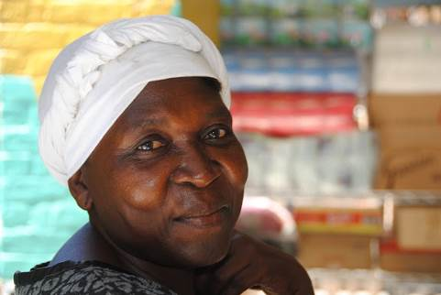
Belmise Petit, a 50-year-old mother of six in Grand Anse, does not have steady work, but is the sole provider for her household. Due to severe arthritis pain she can no longer make money by doing laundry, as she used to.

“There are times I would give my remaining 10 Gourdes ($0.21) to my children, then go to church all day and tell myself I was fasting,” she says. “It helped me cope with the hunger.”

Thanks to CARE’s food voucher program, Belmise can now go to a participating grocery store once a month. She uses her electronic voucher to buy products like rice, beans and cornmeal to feed her family, including two grandchildren. Belmise also helps her neighbor, who’s also struggling. “We do what we can to help each other; she lives so close to me, I could never eat while knowing she’s hungry.”

More than half the population of Haiti lived in extreme poverty before the 2010 earthquake. Rebuilding livelihoods requires a long-term vision and innovative approaches to income generation, job creation, asset protection and access to capital. Financial inclusion and connecting Haiti’s poor to the national economy are key components of CARE’s strategy.

Our programming includes early emergency cash-for-work opportunities, livelihood grants to returnees, business startup grants for women’s solidarity groups, agro-savings schemes, employment creation for trained construction workers and VSLAs. Additional innovative programs are supporting the development of urban and home gardens to reduce the amount spent on food, increase dietary diversity, and for some families provide supplementary income.

Empowering women and improving their access to economic opportunities are crucial steps towards lasting change. CARE’s highly successful VSLA program is a prime example of our community-driven approach. CARE has rolled out the VSLA methodology in both urban and rural areas affected directly and indirectly by the earthquake. By the end of September 2014, 33,466 VSLA members in Haiti had mobilized savings of approximately $1,274,860, by saving a few cents or a dollar at a time.

CARE’s goal is to reach 300,000 men and women in Haiti by 2017 with VSLA membership. Through this network of potential entrepreneurs CARE will support the development of social enterprises – ventures that use business strategies to advance a primary social mission, such as promotion of affordable solar energy, the availability of children’s books, waste management and recycling businesses.

VSLAs are also proven to increase resiliency to disasters by strengthening livelihoods and making funds immediately available to members after an event. This was the case in Haiti following Hurricane Sandy. VSLA members in Grand Anse had immediate access to over $43,000 from savings, allowing members to replace assets and quickly restart livelihood activities. Social funds and emergency also provide a community-based social protection mechanism. And the intangible increase in social cohesion and solidarity are invaluable in responding to issues such as cholera and gender-based violence, and in preparing for future emergencies.

Prévilia Fénélon, a treasurer of her village savings and loan association, counts money at a VSLA meeting. She lost her home and small business – selling charcoal, used clothes and fried foods – in the quake, and ended up living in a temporary camp. With the funds she is saving and the skills training she is receiving through the VSLA, she and her three adult children plan to grow their business and build a new permanent house.
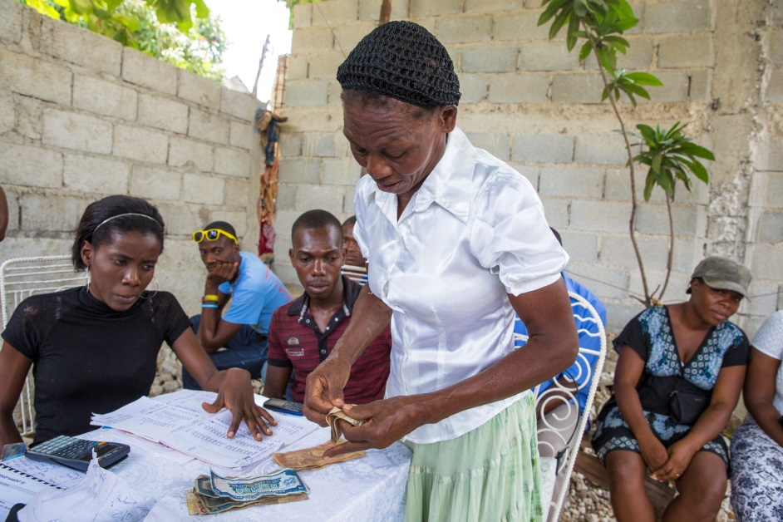

Looking forward

Five years after the country suffered unprecedented losses, Haiti is gradually recovering. Full recovery will require continuous commitment from donors and the international community and most essentially, continuous commitment from the Haitian Government to invest in and support the most vulnerable populations. Weather related disasters are a real and frequent threat, and while many families have been able to recover many others are still extremely vulnerable to future emergencies as evidenced by the ongoing food crisis.

CARE’s commitment to the empowerment of women and the eradication of the poverty and social injustice in Haiti remains unwavering. We will work alongside communities, their government, our partners, and allies to address the underlying causes of poverty and vulnerability: social exclusion, inequality and poor governance.

The future looks bright. The commitment of our partners in recent years has been exceptional and initiatives that CARE started during the emergency response are becoming models to be scaled up at national level. At this critical stage of the recovery, in our partnerships with the Haitian Government across all our programming we will focus on building the capacity of Haitian institutions to provide services, and be accountable to its population, and will advocate for policies and practices to address structural and relationship issues that contribute to gender inequities.

Going forward, CARE’s work in Haiti will focus long-term programming on improved food security and nutrition for chronically food insecure families, quality education for marginalized girls and boys, participatory urban development in informal settlements, sustainable economic development through financial inclusion and social enterprise, and helping families and communities become more disaster resilient. CARE will continue to help Haitian communities respond, prepare and recover from disasters when they arise.

Conclusion

The unprecedented devastation of January 2010 took a tremendous toll on the people of Haiti. The global outpouring of generosity was truly inspiring and Haitians began working hand in hand with helpers from around the world to begin the monumental task of rebuilding.

CARE, with deep roots and more than half a century of experience working in Haiti, took on the challenge, launching our early response in the first hours and days. Along with our humanitarian partners, we succeeded in meeting immediate needs for food and emergency shelter, and in preventing the already horrific death toll from rising due to ancillary threats such as water-borne disease.

Today we continue to work toward the goal of recovery, community development and helping survivors back onto a path of economic self-sufficiency – a longer-term and in many ways more challenging task than the initial response.

Despite the many challenges, CARE remains dedicated to this vital work, which would be impossible without your support and partnership. On behalf of the many thousands of people you have helped us reach, we thank you for your generosity and your confidence in CARE.

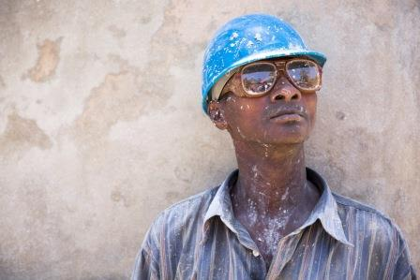
December 2014
Haitians are hard at work rebuilding after the devastating blow their country took five years ago. All they ask is assistance acquiring the skills and tools they need. Says construction worker Ylerne Divert, “I see the community’s role as to give whatever support we can. I’m ready to do anything I can to help the work, because it’s not something I could do on my own.”

United Nations in Haiti, Office for the Coordination of Humanitarian Affairs. Haiti Cholera Response Fact Sheet, Sept 2014
Institute Haïtienne de Statistique et d l’Information, 2012. EMMUS V (DHS), pp. 10-11
Karolinska Institute and Columbia University, May 2010. Internal Population Displacement in Haiti: Preliminary analyses of movement patterns of Digicel mobile phones: 1 January to 11 March 2010
United Nations in Haiti, Office for the Coordination of Humanitarian Affairs. Haiti Cholera Situation Report #29, December 24, 2010
CARE Food Voucher final report
Karolinska Institute and Columbia University, May 2010. Internal Population Displacement in Haiti: Preliminary analyses of movement patterns of Digicel mobile phones: 1 January to 11 March 2010

